Wind speed variation with the distance (Related to Babak Bahrani tree burning experiments)

In this experiment, the initial velocities at the fans are 5.36 m/s (idle wind), 11.17 m/s (medium wind), and 17.88 m/s (high wind). X distance is 7.32 m.

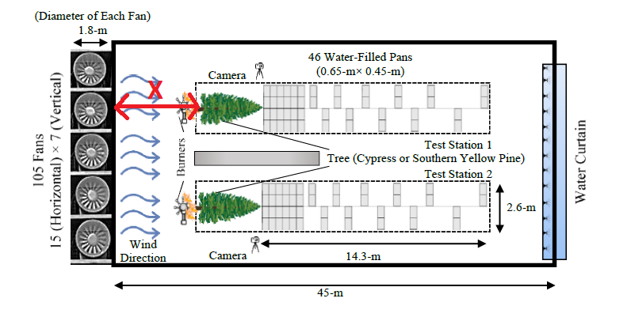

Similar to that, three simulations were completed for given initial wind speeds to find the wind speed at the tree base. The set up is as follows.

|  |  |
| --- | --- |
|  |  |

|  |  |
| --- | --- |
| Inlet velocity m/s (at z=-7.3 m) | Velocity at tree base m/s (at z=0 m) |
| 5.36 | 3.85 |
| 11.17 | 8.19 |
| 17.88 | 13.16 |

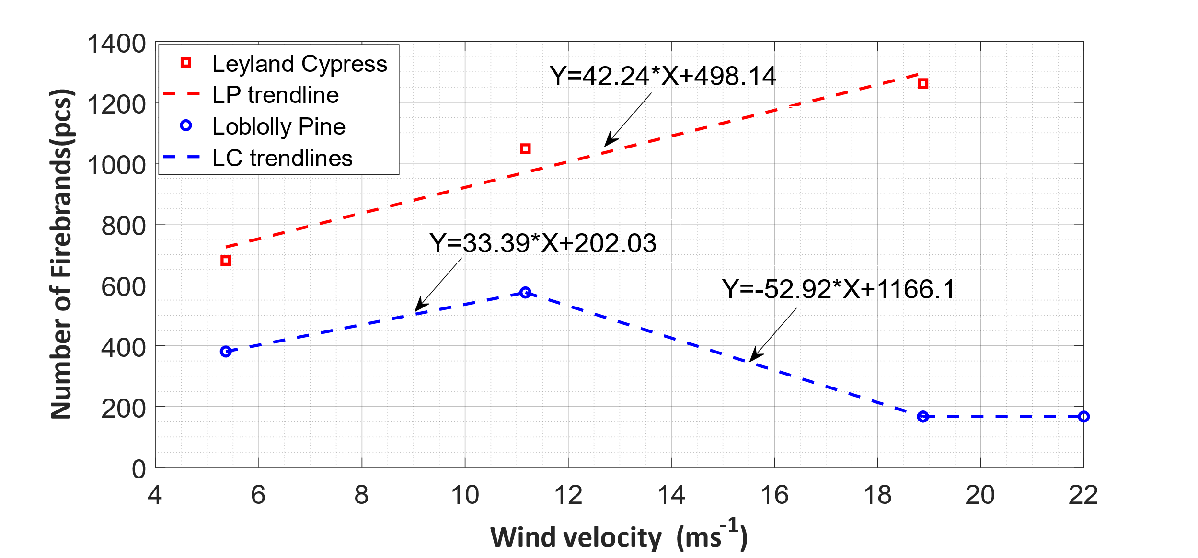

**AS 3959**-Investigate the wind velocity profiles at three locations (back of the fireline, middle of the fireline and front of the fireline)

|  |
| --- |
| **Location** |
| Top of the crown |
| Bottom of the crown |
| Top of the understorey |

|  |
| --- |
| Time average wind velocity vs height at   * back of the fireline * middle of the fireline * front of the fireline) |
| FFDI 100 |
| FFDI 80 |
| FFDI 70 |
| FFDI 60 |
| FFDI 50 |

|  |
| --- |
| Time series wind velocity at back of the fireline  Elevation:   * Top of understorey * Bottom of the upperstorey * Top of upperstorey |
| FFDI 100 |
| FFDI 80 |
| FFDI 70 |
| FFDI 60 |
| FFDI 50 |

Summary

|  |
| --- |
|  |

|  |
| --- |
|  |

|  |  |  |  |  |  |
| --- | --- | --- | --- | --- | --- |
|  | **Average wind velocity (m/s) at the back of the fireline** | | | | |
| **Location** | **FFDI 100** | **FFDI 80** | **FFDI 70** | **FFDI 60** | **FFDI 50** |
| Top of the crown | 13.43 | 11.31 | 10.33 | 9.19 | 8.56 |
| Bottom of the crown | 17.19 | 14.51 | 11.44 | 7.44 | 6.65 |
| Top of the understorey | 4.03 | 3.03 | 2.47 | 1.73 | 1.72 |
| Average velocity (1.5 m to 40.5 m) | 10.49 | 8.93 | 7.60 | 5.94 | 5.54 |